# RT-RPIA: Real-time Resiliency Planning and Investment Analysis tool

**Researchers (WSU)**: *Anurag Srivastava (lead), Asmita Acharya, Sanjita Bhavirisetty, Sanjeev Pannala and K. S. Sajan.*

*This README document is prepared by Sanjita Bhavirisetty (*[*r.bhavirisetty@wsu.edu*](mailto:r.bhavirisetty@wsu.edu)*) from Washington State University.*

## Software Dependency

* PostgreSQL 12 (pgAdmin 4 is included)
* Python 3.8 or later and related libraries required to build RT-RPIA
  + click==7.1.1
  + cycler==0.10.0
  + decorator==4.4.2
  + Flask==1.1.1
  + Flask-JWT==0.3.2
  + flask-marshmallow==0.11.0
  + Flask-SQLAlchemy==2.4.1
  + itsdangerous==1.1.0
  + Jinja2==3.0.1
  + kiwisolver==1.3.1
  + lml==0.0.9
  + MarkupSafe==2.0.0
  + marshmallow==3.5.1
  + marshmallow-sqlalchemy==0.22.3
  + matplotlib==3.3.3
  + networkx==2.5
  + numpy==1.19.1
  + pandas==0.25.3
  + Pillow==8.1.0
  + psycopg2==2.8.4
  + pyexcel-io==0.5.20
  + pyexcel-xls==0.5.8
  + PyJWT==1.4.2
  + pyparsing==2.4.7
  + python-dateutil==2.8.1
  + pytz==2020.1
  + scipy==1.5.4
  + six==1.14.0
  + SQLAlchemy==1.3.15
  + Werkzeug==1.0.0
  + xlrd==1.2.0
  + xlwt==1.3.0

## Installation and Environment Setup

### RT-RPIA

#### Step 1: Install PostgreSQL Database from <https://www.postgresql.org/download/>, and use the following configurations when prompted.

Username: postgresql  
Password: password  
Default Port: 5432

#### Step 2: Install Python 3.8 or later from https://www.python.org/downloads/

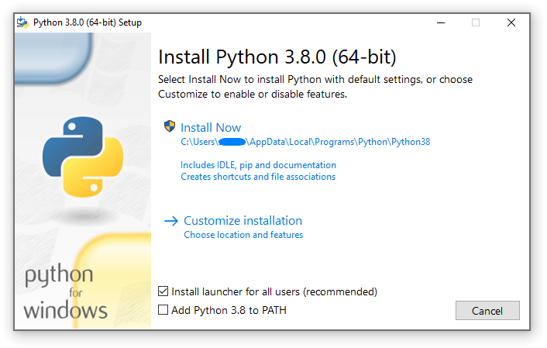

#### Step 3: Open “Command Prompt” and Locate the current directory to “..\RT_RPIA\RPIA-Tool \”. To install required Python libraries in the system environment, use “pip” (or “pip3”) in the command line to install libraries listed in the “requirements.txt” file, i.e.

pip install -r requirements.txt

#### Step 4: Import the Database from a database-dump file.

* Open “pgAdmin 4” and connect to PostgreSQL server using password: “password”

* Create Database: “rpiadb”

* Dump data into Database:
  1. Right-click on the new database “rpiadb” and then click on “Restore”
  2. In filename, browse to location ““..\RT_RPIA\RPIA-Tool \”
  3. Select “rpiadb.sql”
  4. Click “Restore”

#### Step 5: Locate to the directory “..\RT_RPIA\RPIA-Tool \”. Run the RT-RPIA application to check if the required softwares are installed successfully.

python app.py

#### Step 6: Go to “http://127.0.0.1:5000/”, you should be able to see the following webpage.

RT-RPIA:

High-impact low-probability (HILP) events such as hurricanes, snowstorms, heat waves, and floods cause widespread power outages and blackouts. With the increasing challenges concerning the threats to the power systems and the growing need to mitigate the impacts of the HILP events, resilience has become a crucial desirable characteristic for the power grid infrastructures.

The operators within the control center of the power grid need to analyze previous threats as well as predict other possible threats so that pre-planning can be done to mitigate its impact on the overall power system.

RT-RPIA: Realtime Resiliency planning and investment analysis is developed considering the impact of HILP events on the power grid. It comprises of development of planning and analysis for the resilient power grid with hydro generation and distributed energy resources (DERs). Hydro resources need to be coordinated with DERs to meet the grid resilience requirements while meeting water constraints. This tool facilitates the operator to identify the possible threats so that they can visualize and prepare strategies for assets safety, maintain inventory, alert customers beforehand, and reduce its impact on system resilience.

Finally, the qualitative assessment of the tool’s ability is explained by its contribution and effectiveness. It includes how investing in smart grid technologies such as remote-controlled switches, Distributed Energy Resources (DERs) and increased distribution automation can be beneficial for resilience enhancement.

Features:

System Information: This helps the planner and operator to overlook and observe the system conditions from the control room.

Threat Information: This tab provides upcoming threats and its visualization on system nodes that might be prone to threat (i.e., overlapping the map with heat wave taking different colour intensities for threat affected zone).

Manage Asset and crew: This tab is shown in Fig. 6 which includes data tables that help in the estimation of crew and inventory requirements. The operator can predict inventory and crew requirements and compare them with their availability. This helps the operator to prepare for the event beforehand.

Predicted Asset Damage: This tab is built to disclose the expected asset damage based on the known trajectory of abnormal event. It furnishes most probabilistic assets that can be affected by upcoming events.

Resilience Analysis: This tab reflects resilience analysis information for different use cases based on the specific condition and scenario of system. It helps to visualize how adding the technology helps improve the resiliency score of the system.

Resilience Investment Analysis: In this tab a data table displays the considered threat and details about different technology. On the right side, we can see the live map displaying the nodes that can be impacted by predicted threats.

